
Federal scientists: Limit offshore drilling plans
Citing danger to marine life, the National Oceanic and Atmospheric Administration opposes opening large tracts of coast to drilling and recommends buffer zones off Santa Barbara.
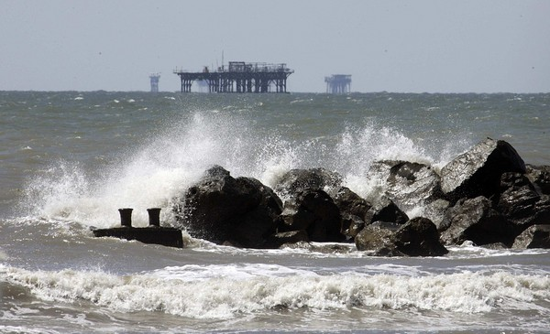
Waves break in the Gulf of Mexico off Louisiana. In nonbinding recommendations, NOAA opposes new drilling in the Gulf of Mexico and sharply critiques the Bush-era offshore leasing plan. (Bill Haber / Associated Press / May 20, 2009)
Related
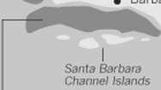Graphic: Drilling leases affected
NOAA comments on leasing program draft
By Jim Tankersley and Josh Meyer
October 12, 2009
E-mail
Print
Share
Text Size

Reporting from Washington - The federal government's top ocean scientists are urging the Interior Department to drastically reduce plans to open the coast to offshore oil and gas drilling, citing threats to marine life and potentially devastating effects of oil spills in Arctic waters.

FOR THE RECORD:The headline on an earlier online version of this story incorrectly said that federal scientists oppose drilling plans. Although they have urged that the plans be curtailed, they have not opposed drilling entirely.

The recommendations by the National Oceanic and Atmospheric Administration are informal and not binding. But if adopted, they would restrict development in some of the nation's most resource-rich untapped offshore areas and mark a significant departure from the pro-drilling policies of the George W. Bush administration. They also give added -- and official -- weight to environmentalists' concerns.
In a letter sent to Interior officials last month, NOAA recommended excluding large tracts of the Alaska coast, the Atlantic seaboard and the Gulf of Mexico from Interior's draft offshore drilling plan for 2010 to 2015.
NOAA recommends establishing buffer zones around the Southern California Ecological Preserve off Santa Barbara. In addition, it suggests that its broader recommendations, such as taking greater account of drilling's effects on marine life, could affect potential lease sales off California.
The agency calls for a ban on drilling in the Arctic until oil companies greatly improve their ability to prevent and clean up oil spills. And it asks Interior to delay new drilling plans until an Obama administration ocean policy task force completes its work late this year.
The comments, dated Sept. 9 and obtained by the Washington Bureau, were included in a letter to Interior officials from NOAA Administrator Jane Lubchenco. They include an often sharp critique of the offshore leasing plan, developed under Bush, that would open swaths of the California coast and other areas to new drilling.
NOAA says the leasing plan's assessment of the risks of drilling, such as oil spills, is "understated and generally not supported or referenced."
For example, in Alaska's North Aleutian Basin and Chukchi Sea, the agency says it is "very concerned about potential impacts to living marine resources and their habitats, viable commercial and recreational fisheries, and subsistence use of marine resources as a result of future lease sales, exploration, and development."
The recommendations echo concerns raised by an array of environmental and local community groups, fishermen, Alaska Natives and scientists, said Dr. Richard Steiner, a marine biologist at the University of Alaska who has battled Interior over Alaska offshore drilling.
"The significance is that here we have one federal agency supporting what we have been saying all along regarding the push to lease offshore in Alaska," he said. The agency's comments, Steiner added, "put Interior in a corner in all of this."
The recommendations reflect the ascendance at NOAA of environmentalists such as Lubchenco, a marine ecologist who has been outspoken on ecosystem issues and climate change.
"It is refreshing to hear the voices of marine scientists who were silenced for the past eight years," said Jeff Ruch, executive director of Public Employees for Environmental Responsibility, which has publicized documents that show Bush officials overruling or downplaying environmental concerns.
"If NOAA's warnings are not heeded," Ruch added, "Interior's offshore leasing plans will again be ensnared in litigation."
NOAA urges the Minerals Management Service -- the Interior division that handles offshore drilling -- to consider ocean ecosystems, coastal communities and other environmental factors when finalizing a leasing plan.
The agency stresses the challenges of cleaning up an oil spill in remote, icy waters, which NOAA says would be substantially more difficult than cleaning up a spill elsewhere.
The recommendations highlight the competing pressures on Interior Secretary Ken Salazar as he weighs whether to amend the Bush-era leasing plan.
Republicans have accused Salazar of dragging his feet and stalling domestic energy production, in part because he extended the time for the public to comment on the plan.
Rep. Doc Hastings of Washington, the top Republican on the House Natural Resources Committee, recently accused the administration of placing "a de facto ban on offshore drilling."
The comment period ended last month, with more than 450,000 submissions, including some from conservation groups, governors and industry representatives.
In a comment representative of the oil industry, BP America enthusiastically supported the Bush plan, writing: "The oil and gas exploration and development sector has a strong record of environmental and safety performance. We believe that if new areas are opened, they can be leased, explored and developed safely and in an environmentally sensitive manner."
Through a spokeswoman, Salazar remained noncommittal Sunday about the NOAA recommendations. Kendra Barkoff said in a statement that the secretary "welcomes the ongoing input and expertise of NOAA and other federal agencies and looks forward to continuing these discussions as he moves toward decisions that will help us build a comprehensive, responsible offshore energy strategy for the country."
Last month, in a news release announcing the end of the comment period, Salazar said the future leasing plan "must take into account several key considerations, including areas of the ocean that are critical to military training and the nation's defenses; other economic benefits of the oceans, including fisheries, tourism, and subsistence uses; environmental considerations; existing oil and gas infrastructure; interest from industry; and the availability of scientific and seismic data."
jtankersley@latimes.com
josh.meyer@latimes.com

